This pipeline measures how closely AI‑generated meshes (from single RGB images or text prompts) match ground‑truth CAD models, using a suite of geometric metrics.

1. Pair AI ⇔ GT Models
- Discover AI outputs: Scan AI_DIR/*/*.obj for every generated mesh.
- Match to GT: For each basename, try:
  - Internet‑sourced CAD (internet_gt_models/<name>.obj)
  - LINEMOD CAD (linemod_gt_models/<name>.ply)
- Record pairing: Save (mesh_ai, mesh_gt, method, category, timestamp, gt_source) for downstream evaluation.

2. Per‑Model Evaluation
For each paired (AI, GT) mesh:
- Setup
  - Create results/<method>/<category>/<timestamp>/<model>/
  - Initialize JSON metadata: method name, category, GT source, file paths.
- Load Meshes (loader.py)
  - Use trimesh.load() (handles .obj, .ply, Scene, lists).
    - A single Trimesh object,
    - A Scene containing multiple named geometry nodes, or
    - A Python list of Trimesh instances.
  - To unify these into one mesh, we:
    - Call scene.dump() on a Scene to get its sub-meshes, or use the list directly;
    - Use trimesh.util.concatenate(...) (or the equivalent sum() trick) to merge all sub-meshes into a single Trimesh with combined vertex and face arrays. This guarantees that downstream steps (scaling, Iterative closest point (ICP), metric computation) operate on one cohesive mesh rather than multiple fragments.
- Preprocessing (preprocessing.py)
  - Centering: translate both meshes so center of mass is at (0,0,0).
  - Safe scaling: match AI volume to GT volume (if watertight), else convex hull, else bounding‑box diagonal.
  - Record applied scale factor in metadata.
- (Optional) Visualization (visualizer.py)
  - Scatter DEFAULT_NUM_SAMPLES points on AI (green) and GT (red) meshes at three stages: raw, after scaling, after ICP.
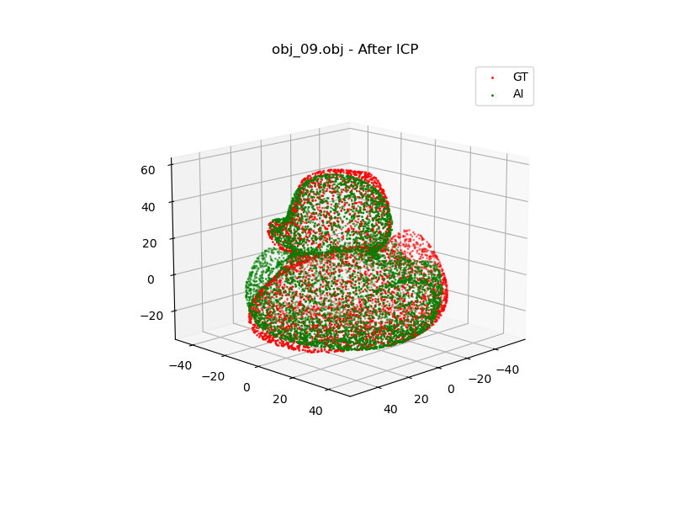
- Coarse + Fine Alignment (refiner.py)
  - Apply RANSAC transform only if fitness > 0.1 to avoid spurious global alignments.
  - Multistage ICP: coarse (3×VOXEL_SIZE) → medium (VOXEL_SIZE) → fine (0.2×VOXEL_SIZE), each stage initialized from the last.
- Metric Computation
  - Instantiate each metric with (mesh_gt, mesh_ai, output_dir):
    - Chamfer Distance: average bidirectional squared‐distance between DEFAULT_NUM_SAMPLES point samples. Note: we normalize the chamfer distance based on the bounding box of the object for it to become unit-less (this is because using safe scaling, the objects sizes differ initially and it is not consistent to compare objects with initially different scales)
    - Earth Mover’s Distance (EMD): optimal matching cost over EMD_NUM_SAMPLES points via Hungarian algorithm. Note: this is also normalized the same way as for Chamfer Distance
    - Hausdorff Distance: max nearest‐neighbor error over DEFAULT_NUM_SAMPLES samples. Note: this is also normalized the same way as for Chamfer Distance
    - Voxel IoU: grid‐based overlap at resolution DEFAULT_VOXEL_PITCH
    - Normal Consistency: cosine similarity of matched normals, flipped for sign ambiguity
    - Mean Curvature Error: average local curvature difference on DEFAULT_NUM_SAMPLES points
  - Each metric’s compute() returns a raw score; get_class(score) buckets into quality labels using thresholds from config.py.
- Save & Summarize
  - Write metrics.json in the model’s folder (raw scores + labels).
  - Append to global results/summary.json.
  - Print per‑method/category summary to console.

Definitions
Trimesh: a triangle‐based 3D surface representation.
Safe Scaling: When comparing an AI-generated mesh to a ground-truth (GT) mesh, it is crucial that they be at roughly the same scale before attempting fine alignment (ICP/RANSAC) or computing metrics. However, raw AI outputs may come at arbitrary sizes or units, and they may be imperfect (e.g., holes, missing faces). It is a multi-stage, robust method scaling AI-generated meshes to match ground-truth dimensions (in this case the LINEMOD .ply objects) by trying progressively simpler but cruder measures of “size” until one is usable such as (in order) watertight mesh volume, convex-hull volume, or bounding-box diagonal when earlier measures are invalid.
Scale = (Volume-GT / Volume-AI)^(⅓)
Watertight: A “watertight” mesh means there are no leaks, every edge and face fits together so the surface completely encloses some interior space. The “volume” is then just the amount of space inside that sealed shape.
Watertight Mesh Volume: check that the mesh is closed (no missing faces or dangling edges), and if so, it can add up small tetrahedron volumes formed between each triangle of the surface and a reference point (often the origin) to get the total enclosed volume. If the mesh had holes, this calculation wouldn’t reliably represent an interior space, which is why “watertight” is a key requirement for this direct volume measure.
Convex-Hull Volume: The convex hull of a mesh is the smallest “convex” shape that encloses all vertices of the mesh, think of stretching a rubber band (in 3D) around the model. Even if the original mesh is not watertight or has holes, its convex hull is well-defined and typically watertight.
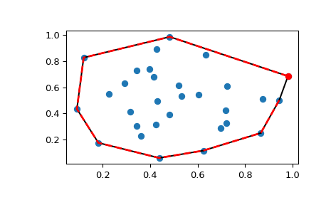
Bounding-Box Diagonal: the length of the diagonal of the axis-aligned bounding box of the mesh, used as a fallback size metric when volume cannot be computed.
Fast Point Feature Histograms (FPFH): local 3D geometric descriptor for a point in a point cloud, capturing the distribution of angular relationships between the point and its neighbors.
- Robust feature matching: When aligning two point clouds that may start with arbitrary relative pose, direct nearest-point matching is unreliable. FPFH descriptors allow matching points with similar local geometry, increasing the chance of finding correct correspondences even under large misalignments.
- Initialization for RANSAC: We use FPFH to propose candidate correspondences between the GT and AI point clouds. Although many matches will be incorrect, RANSAC can still find a consistent subset.
- Scale & rotation invariance: Since FPFH is built from relative angles and distances normalized in local neighborhoods, it does not depend on global positioning or orientation.
- Intuitive Example:
  - Imagine two 3D scans of a banana: one is the GenAI output, one is ground truth. They might be rotated differently, shifted, or even slightly deformed locally. We want to find which parts correspond.
  - Pick a point on the GT banana, say on a slightly curved region near the tip. Around that point, there’s a small patch of surface (neighbors within some radius). That patch might look like a gentle curve.
  - FPFH “fingerprint”: For that GT point, we compute a histogram summarizing how the surface bends in that patch: are normals roughly all pointing similarly (flat), gradually changing (gentle curve), or sharply changing (edge-like)? This histogram is the FPFH descriptor for that point.
  - Find similar patches: Now in the AI banana scan, we look for points whose FPFH histogram is similar, i.e., their local patch “bends” in a similar pattern. Those become candidate matches.
  - Even if the overall bananas are differently oriented in space, their local patches share the same intrinsic shape: FPFH captures that intrinsic shape, ignoring global position/orientation.
- Step-by-step:
  - Choose a support radius (e.g., 5× a base scale). This defines “how big” the local patch is around each point.
    - Basically we uniformly (or randomly) sample DEFAULT_NUM_SAMPLES (e.g. 20000) points on the surface. Each sampled point P defines one patch: the local neighborhood around P. So you will compute 20k descriptors.
    - For us we do VOXEL_SIZE * 5 which means for each center point P, gather all neighbors within a sphere of radius 5×VOXEL_SIZE (or up to max_nn points which is 100 in our case). That sphere is your “patch.” If VOXEL_SIZE = 7 mm, radius = 35 mm.
  - Estimate the normals. For each sampled point P, use its patch neighbors to estimate a surface normal at P.
  - Compute Simplified PFH (SPFH) for each center point P.
    - In P’s patch, for every neighbor Q:
      - Compute a few simple angular features between the vectors and normals at P and Q (e.g. angle between normals, orientation of the line P→Q relative to the normals).
      - Bin these angles into a small histogram.
    - The resulting histogram (from only P’s direct neighbors) is called the SPFH of P. Intuitively, SPFH encodes “how the surface bends around P” based solely on immediate neighbors.
  - Build FPFH by aggregation: combine P’s own SPFH with a weighted sum of neighbors’ SPFHs to incorporate slightly larger context, producing a fixed-length descriptor per point.
  - Collect descriptors for both clouds: After computing FPFH on the sampled GT point cloud and on the sampled AI point cloud, you obtain two sets of histogram vectors (one per sampled point in each cloud). These form your descriptor datasets.
  - Ready to be inputted into RANSAC
RANSAC (Random Sample Consensus): Robust estimation algorithm designed to fit a model to data containing many outliers. In our context, the “model” is a rigid-body transform (rotation + translation) aligning two point clouds, and the “data” are candidate correspondences (e.g., between FPFH descriptors)
- Overview:
  - Randomly pick a small subset of correspondences (hoping some picks are all correct) between points in the AI cloud and points in the GT cloud. These correspondences arise from matching FPFH descriptors (handled automatically inside Open3D’s RANSAC routine).
  - Random Sampling & Hypothesis: RANSAC repeatedly picks a small random subset of these correspondences (e.g., 4 pairs), computes the rigid transform (rotation + translation) that best aligns those few pairs, and treats that as a candidate alignment hypothesis.
  - Consensus Test (Inlier Counting): For each hypothesis, RANSAC applies the transform to all AI source points in the correspondence set, then checks how many of those transformed points land “close enough” to their matched GT points (within a geometric distance threshold). Those that land within the threshold are counted as inliers for that hypothesis.
  - Best Transform Selection: Over many random samples, RANSAC tracks which hypothesis yields the largest inlier count (or fraction). That becomes the best-found coarse transform.
ICP (Iterative Closest Point): for fine alignment.
- Correspondence step: For each point in the source cloud, find the closest point in the target cloud (within some maximum distance).
- Estimation step: Compute the rigid transform (rotation + translation) that minimizes the alignment error. With point-to-plane ICP, the error is measured along the target normals, which often yields faster and more accurate convergence when normals are available.
- Apply transform: Update the source by this transform.
- Repeat until convergence or until the change is small. (if the source is still somewhat misaligned, some nearest neighbors may be far away or correspond to wrong regions. A maximum correspondence distance helps ignore those outliers)
Coarse: handles big corrections with low precision.
Fine: handles tiny corrections with high precision.
Multistage ICP: we start with a large max-distance to allow broad corrections, then progressively shrink it so only close, reliable correspondences remain. How we do it:
- Stage 1 (coarse):
  - thresh = VOXEL_SIZE * 3 ≈ 21 mm.
  - Allows matching source points to target points up to ~21 mm apart. This tolerates larger misalignments and brings clouds roughly together.
- Stage 2 (medium):
  - thresh = VOXEL_SIZE ≈ 7 mm.
  - Now only correspondences within ~7 mm are accepted; outliers or far-away matches from the coarse stage are discarded, refining alignment.
- Stage 3 (fine):
  - thresh = VOXEL_SIZE * 0.2 ≈ 1.4 mm.
  - Very strict: only very close neighbors contribute, polishing the alignment to sub-millimeter (relative) accuracy.
Chamfer Distance: measures how close each point on one shape is to its nearest point on the other shape, in both directions. If the surfaces are close, Chamfer Distance is low. If they’re far apart or mismatched, the distance is high. So in short “Average of all squared distances in both directions”
Chamfer = Avg squared distance each GT point has to AI + Avg squared distance each AI point has to GT (units: mm^2)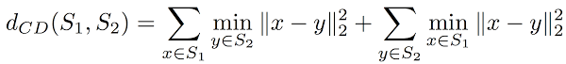
Hungarian Algorithm: Finds the minimum‐cost perfect matching in a weighted graph with 2 separate groups.
Earth Mover’s Distance: average cost to transport mass between two point clouds or just minimum total effort needed to turn one point cloud into another.
- Analogy: GT point cloud is a pile of dirt, and the AI point cloud is a set of holes. EMD tells you how much "work" it takes to fill all the holes with the dirt.
- Detects structural differences (e.g. if one mesh is shifted or fragmented)
- Used in GANs, shape synthesis, point cloud alignment
- Matches points to globally optimal match, not nearest neighbor (like chamfer distance)
  - Sample points on both meshes. Choose the same number of random points on the ground-truth mesh and on the AI mesh (e.g. 1 000 each) so you have two clouds of equal size.
  - Build the transport cost table. For every GT sample and every AI sample, measure the straight-line (Euclidean) distance between them. You end up with an N×N table where entry (i, j) is “how far dirt pile i would have to move to fill hole j.”
  - Find the minimum-effort matching. Treating that distance table as a “cost” matrix, solve the optimal one-to-one assignment that makes the sum of chosen distances as small as possible. This is the Hungarian (linear-sum-assignment) algorithm, which pairs each GT point to exactly one AI point to minimize total movement.
  - Collect matched distances. Once you have the pairing, look up each matched distance in your cost table. You’ll have one distance per GT→AI match, representing how far that “dirt” traveled for that assignment.
  - Compute the average transport cost. Add up all the matched distances and divide by the number of points. This is the average work per point needed to transform the GT cloud into the AI cloud.
Hausdorff Distance: (strictest surface metric) While Chamfer Distance looks at average distances between points on two surfaces, Hausdorff Distance measures the worst-case deviation. So in short “Single worst-case distance (max of closest)”
- “What is the largest error when I try to match points from one surface to another?”
- Even if 99% of the surfaces match, if one corner is far off, Hausdorff Distance will spike.
- Hausdorff is the biggest distance from any point to its nearest neighbor on the other shape. Or in other words, Hausdorff is the maximum distance of the biggest of distances of each object by taking the closest point of each point.
Voxel: (short for “volumetric pixel”) is like a 3D cube, just like a pixel is a 2D square on a screen. Think of a voxel grid as a 3D chessboard where each cube can either be: Occupied by the mesh or Empty. For Voxel IoU we define the size of each cube to be 6 mm (this is also due to computational power). The number fits both computation and precision in this (found via trial and error).
- Example: for a 100mm x 100mm x 100mm object and 6mm pitch, you get about
  - (100 / 6)^3 ~ 4641 voxels total
IoU (Intersection over Union): measures how much two shapes overlap relative to their combined size. Think of two 3D objects, if you place one inside the other perfectly, they’ll have perfect overlap 1.0 (100%).
- Mathematical definition → IoU = Volume_Intersection / Volume_Union
- Intersection is the common volume shared by both meshes
- Union is the total volume covered by either mesh
  - Union = Volume-AI + Volume-GT - Volume_Intersection
- Because we have genAI models which can happen that they are not watertight (boolean IoU requires this) we will go for the voxel IoU.
  - We create the voxel grid
  - For each voxel center (i.e., a point in space), we check if it is inside the GT mesh or AI mesh (self.mesh_gt.contains(points) where we return true or false)
  - Count Overlap and Union
    - Intersection = #voxels where (inside GT AND inside AI)
    - Union= #voxels where (inside GT OR inside AI)
  - Now that we have both Intersection and Union we just apply the formula
Normal Consistency: measures how well their surfaces face the same direction. (Are the surfaces facing the same way at each point?). Each surface point has a normal vector: a unit vector pointing "outward" from the surface.
- For every point on the AI mesh, find the nearest point on the GT mesh.
- Compare the normal vectors at both points using the dot product:
  - cos(θ)=normal-vector-AI​⋅normal-vector-GT
    - If they’re aligned: dot = 1
    - If opposite: dot = –1
    - If perpendicular: dot = 0
- You then compute: Normal_Consistency = 1 - mean_angle_difference / 180_degrees​
Variance: average squared distance from the mean (one variable).
Covariance: measures whether two variables “vary together” (positive), “opposite” (negative), or “independently” (near zero). → average product of deviations (two variables).
Covariance Matrix: “A table of all pairwise covariances”. When you have data in more than two dimensions, say 3D points (x,y,z), you can ask:
- How does x vary with itself? (that’s just variance of x)
- How does x vary with y? (that’s covariance of x,y)
- How does x vary with z? (covariance of x,z)
- …and similarly for y with y, y with z, and z with z.
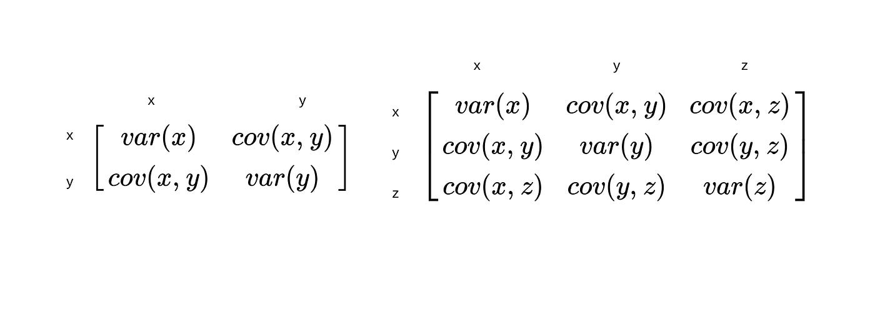
- The diagonal entries are variances (how spread out each coordinate is).
- The off-diagonals are covariances (how each pair of coordinates varies together).
PCA (Principle Component Analysis): Find the directions in space where your data (the neighbor points) “spread out” the most and the least.
- Example: think of it as fitting an ellipsoid around your points.
  - The longest axis points along the direction of greatest spread.
  - The shortest axis points along the direction of least spread.
- Orientation & principal axes: The eigenvectors give you a natural coordinate frame for the shape. You can “rotate” your model so that its longest axis aligns with v3, its next longest with v2, etc.
- Dimensionality reduction: If λ3 is huge but λ1 is near zero, your data is almost planar, so you could drop one dimension and still explain nearly all the variation.
- Local surface geometry: On a small patch, the smallest eigenvalue measures flatness vs. bumpiness (that’s how we estimated curvature).
- Goal: Find the orthogonal directions in which a set of points “spreads out” the most and the least.
  - Gather the local patch. Around the point you care about, collect its nearby neighbors, say the 30 points closest to it on the surface.
  - Find the patch’s center. Compute the average position of those neighbor points; that gives you the “center” of that little cloud.
  - Reposition the points. Shift every neighbor so that this center moves to the origin. In other words, subtract the center from each point’s coordinates, so you’re working with zero-mean data.
  - Measure how they spread. Build a 3×3 “spread” matrix (the covariance) that captures how much those shifted points vary along and between the X, Y and Z axes.
  - Extract the main directions. Do an eigen-decomposition of that matrix. This gives you three special directions (the eigenvectors) each paired with a number (the eigenvalue) that says how much the points stretch in that direction.
  - Pick the smallest stretch. Look at the three stretch-numbers and choose the smallest one. That direction corresponds to how “thin” the patch is, in practice, it aligns with the surface normal, and its magnitude tells you how flat versus curved the patch is.
K-D tree: organize your points by chopping space in half again and again, so nearest-neighbor queries become a quick walk down a tree rather than a slow scan through every point. For a quick simple example (https://www.youtube.com/watch?v=TLxWtXEbtFE)
Mean Curvature error: average of how a surface bends in all directions at a point. It captures local detail that position-based metrics (Chamfer, Hausdorff) miss.
- Two shapes might have similar silhouettes and even aligned surfaces, but if one is smooth and the other is bumpy, the curvature will be different.
- Pick sample points on both meshes. Randomly choose the same number of points on the ground-truth mesh and on the AI mesh so you have two clouds of sample locations.
- Estimate curvature at each sample. For each cloud:
  - For each sample point, look at its nearby neighbors, compute how those neighbors spread in 3D (via PCA), and convert that spread into a single curvature number H (smallest eigenvalue divided by the sum of all three eigenvalues).
  - At the end you have one curvature value for every sampled point on each mesh.
- Link AI points to GT curvature. Build a spatial search structure (a k-d tree) on the GT sample points. Then for each AI sample point, find which GT sample is closest in 3D space.
- Measure local curvature difference. For each AI point, take the absolute difference between its own curvature and the curvature of its matched GT neighbor. That gives you one curvature‐error value per AI sample.
- Compute the average error. Add up all those per-point curvature errors and divide by the number of samples. The result is your mean curvature error, a single number in inverse millimeters.

